Solid State Drives
These are the latest in drive technology that we have in the computer industry. They are totally different from the other drives in that they do not consist of moving parts. They also do not store data using magnetism. Instead, they make use of flash memory technology. They make use of integrated circuits or semiconductor devices to store data permanently, at least until they are erased. Here are some of their advantages.
- Faster data access.
- Less susceptible to shock.
- Lower access times and latency.
- Durability.
- Less power usage
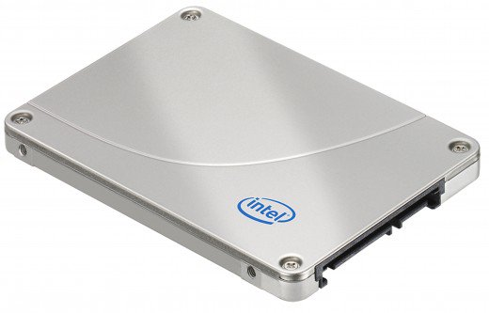

SATA: This is the most common connector used in laptops. These come in SATA 2 and SATA 3 versions, supporting 3.0 and 6.0 Gbps respectively.
SATA drives come in two form factors. 2.5" which goes into laptops and looks like this when it is magnetic:
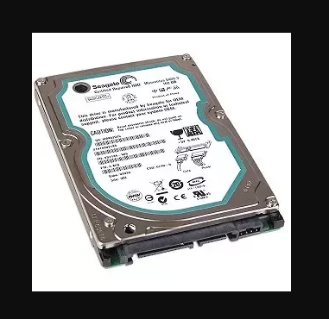
PCIe: This is a very recent technology which comes in select Ultrabooks like the Macbook Air. You can buy these for desktops, but they are quite expensive. However, they are insanely quick. I know of some that can hit 24 Gbps, and there are even faster versions available.
For laptops, they look like this:
